“Beginning Project Management”

Course Plan

By

Max Smith

Beginning Project Management is designed to give the student an understanding of the basic components of Project Management, its methodology and tools. This is a 48 hour course that covers 10 study units. It will meet for 13 weeks, 3 times per week for a 1 hour lecture and presentation and for 10 weeks of computer lab session with MS Project.

The practice of Project Management occurs in nearly all workplace settings. This course meets the requirements of “California Career Technical Education Model Curriculum Standards” by providing instruction in the principles and methodology of Project Management. It is directly applicable for students who choose the career paths where the standard applies as indicated in the following chart, and it appropriate for those teaching courses in these career paths so they are able to imbed Project Management concepts into their courses.

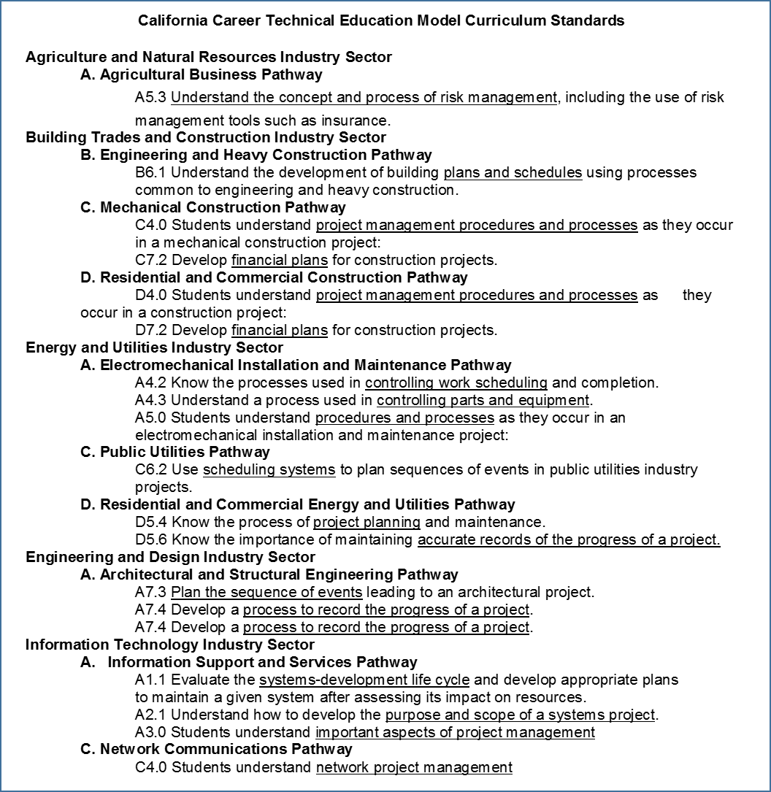

Unit 1- Overview of Beginning Project Management

This 3-hour unit of study will be delivered in the first week of the course. It will consist of 3 lesson plans. The first of these the students will be an Introduction and provide information on their backgrounds, their interest in taking the course, and goals for using project management. The instructor will provide his expectations for the course and the requirements for receiving a passing grade. The other two lesson plans provide an overview of the other 9 Units. At the end of this unit the students will know the history of the development on modern project management methodology and how it may have evolved to the “Guide to the Project Management Body of Knowledge”) PMBoK. At the conclusion of the unit the students will be able list the nine components and describe how they contribute to managing a project. The unit will conclude with a 10 question multiple choice quiz. In the lab session the student will be introduced to MS Project.

Unit 2 – Managing the Scope

This 6-hour unit of study will be delivered in 2 weeks of lecture and demonstration, and 1 week of computer lab with MS Project. The students will know how to develop a mission statement that includes input from all stake holders. They will how to both write and analyze a SOW (Statement of Work). They will be able to develop a Work Breakdown Structure (WBS) down to the lowest level of a Work Package (WP) and include precedence of the WP in relation to the other WPs. They will describe a process for managing change and be able to develop the format for documenting and managing the change process. The unit will conclude with a 10 question multiple choice quiz. In the lab sessions the student will load the work breakdown structure into MS Project.

Unit 3 – Managing the Schedule

This 6-hour unit of study will be delivered in 2 weeks of lecture and demonstration, and 1 week of computer lab with MS Project. The student will be able to describe the various types of schedules and where they are most appropriate. Schedules may be built in a variety of ways and the student will be able to demonstrate how a schedule is developed from the WP. The student will develop a preliminary schedule for the House Project to be compared later to the Gantt Chart from MS Project. The student will develop an “activity network” that corresponds to this preliminary schedule. The critical path will be shown in activity network will be compared later with the results from MS Project. The unit will conclude with a 10 question multiple choice quiz. The lab session will be devoted to building the project schedule with MS Project and how to optimize the schedule.

Unit 4 – Managing the Financials

This 6-hour unit of study will be delivered in 2 weeks of lecture and demonstration, and 1 week of computer lab with MS Project. The students will learn the different techniques for estimating cost and be able to estimate the cost for building the project house. The student will learn how cost are spread over the life cycle, the nomenclature for actual and budgeted cost, and cost variance. The student will take the role of a contractor learn how the revenue cycle determines profitability for the project. The unit will conclude with a 10 question multiple choice quiz. In the lab sessions the student will create the life cycle chart (schedule vs. time) and provide proper annotation.

Unit 5 – Managing Quality

This 2-hour unit of study will be delivered in two lecture and demonstration sessions. The student will learn the concepts of quality and how to apply these to the management of a project. The student will identify which Quality Tools should be applied to the House Project. Optional reading will be “Zen and the Art of Motorcycle Maintenance”. The unit will conclude with a 10 question multiple choice quiz.

Unit 6 – Managing Risk

This 2-hour unit of study will be delivered in two lecture and demonstration sessions. The student will learn the concepts of risk and how to apply these to the management of a project. Techniques for risk avoidance and mitigation will be reviewed and applied to House Project. This will be demonstrated in a report by the student on the risks in building the House Project including which risks may be accepted, which can be avoided, which can be mitigated and how this may be accomplished. The unit will conclude with a 10 question multiple choice quiz.

Unit 7 – Managing Human Resources

This 2-hour unit of study will be delivered in two lecture and demonstration sessions and one hour lab session with MS Project. Leadership styles and organizational types will be reviewed and discussed. Conflict resolution will be reviewed and discussed with techniques for resolution. Projects most often are done in a matrix organization, so the student will learn how to assign resources from a matrix structure into the MS Project work packages. This will be completed in the 1-hour lab session where the student will load labor requirements into the MS Project work packages. The unit will conclude with a 10 question multiple choice quiz.

Unit 8 – Managing Procurement

This 2-hour unit of study will be delivered in two lecture and demonstration sessions and one hour lab session with MS Project. Procurement is typically done for manpower and/or material and is accomplished by a contract. Contract types and their attendant risk will review and discussed along with the negotiating process. This unit is accompanied by a 1-hour lab session where the student will load material costs into the MS Project work packages. The unit will conclude with a 10 question multiple choice quiz.

Unit 9 – Managing Communication

This 2-hour unit of study will be delivered in two lecture and demonstration sessions and one hour lab session with MS Project. Communication is rated by Project Managers as the number one required skill. Oral, written and non-verbal communications will be reviewed and discussed. This will include peer to peer, Project Manager with Team, Project Manager with Management and Sponsor, and Project Manager with external organizations, i.e. Customer, Government and others. The unit will conclude with a 10 question multiple choice quiz.

Unit 10 – Managing Integration

This 2-hour unit of study will be delivered in two lecture and demonstration session. Integration is a relatively new addition to the PMBoK methodology. The integration of the above Units into the overall methodology will be reviewed and discussed as will the physical components of the project itself. The unit will conclude with a 10 question multiple choice quiz.

Review Session 1 – Completing the Project Plan in MS Project

This is a 1-hour lab session for the students to complete and present their Project Plan.

Review Session 2 – Course Review

This will be a 1-hour classroom session to take an examination that is composed of 100 sample questions from the PMI Certification Examination. 70% correct answers or better will receive 20 points toward the final grade.

Course Schedule:

